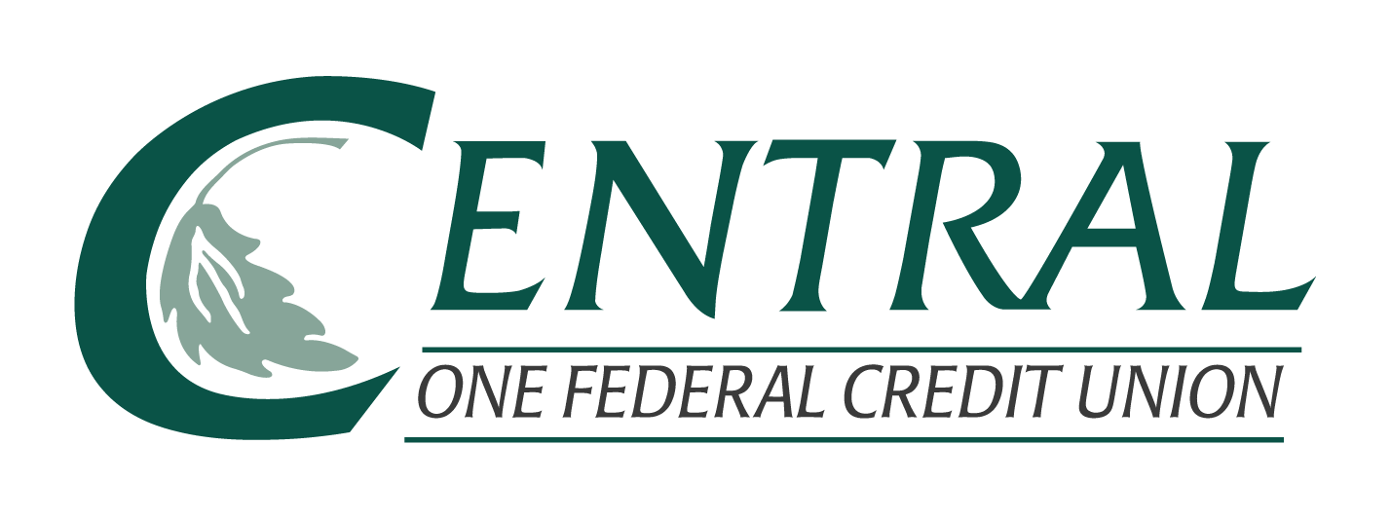

Request for Contribution
Central One Federal Credit Union is committed to supporting and strengthening the communities of Central Massachusetts.

Please complete the following form and submit it with any supporting documentation.
Contact Person ___________________________ Date of Request ____________
Telephone Number ________________________
Email Address __________________________________________________________
Name of Organization ____________________________________________________
Address of Organization __________________________________________________
______________________________________________________________________
*Please answer the questions below. Use a separate sheet of paper if needed.
- Are you or is someone in your immediate family a Central One member?
If so, who?

- What amount is being requested?

- What will the contribution be used for?

- How will Central One be recognized?

- What are your deadlines?

Please email the completed form to member_support@centralfcu.com
or bring it to your local Central One branch.

